My name is Aslam Shahin. I came as a refugee to the Netherlands because of the war in Afghanistan. After I finished school in the Netherlands, I came to the UK to study at University. I have done courses in translation as I speak many languages. I am now studying for a degree in Youth and Community Development.
Since I came to the UK, I have been working to help people. I help people as a translator when they need to speak to lawyers about their asylum cases. I try to help other people from Afghanistan, who live in my local area, Croydon.
A few years ago, I worked with a charity called Compass to set up a group for young male refugees in Croydon. This group is now run by Young Roots and Compass and I have worked there as a volunteer and staff member since it began in 2010. Boys can come to the group for help with their problems and to meet friends. We have helped lots of young people at the group with their immigration, housing and other problems. Lots of young people talk to me about their problems at youth groups or even if I just see them in the street because they know will try to help them.
Doing this work has also helped me. I have been able to practice my own language with the young people from Afghanistan as I had lots some of these skills since left my country when I was 9 years old.
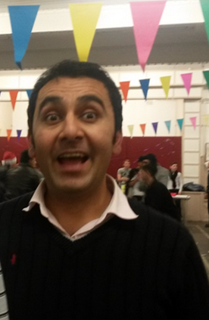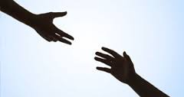

My name is Bazan. I am from Kurdish Iran. I have been in the UK for 7 years. I came here because I had serious political problems in my country. It took me 40 days to get here travelling overland by walking, car and train.
I live in London now. I spend time with my friends, watching football and working in a barbers shop. I have been volunteering to help other young people at the Young Roots weekly boys youth group.
Since I’ve been in the UK, I’ve tried to help other people with their problems. I met a blind man from Iraq, who now has British citizenship. I took him to do his shopping and took him out to the park. Anytime he wants help, I am there.
I helped another friend, who had mental health problems. I went to his house and I was with him when we went to college. I encouraged him to get better. Now he is looking after me too.
I helped another Kurdish man who I met through a friend. Although he had refugee status he was homeless after coming out of hospital when he had to have surgery. I let him stay with me for a month and I brought him to Young Roots and to the Red Cross to get help with his housing.
Other refugees have helped me too. My Kurdish friend helped me when I was homeless. He gave me food and I stayed with him sometimes.
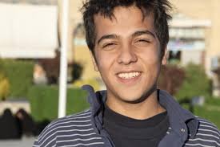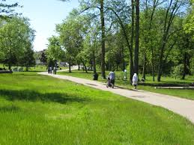

My name is Suleiman. I come from West Sudan. I arrived in the UK two years ago after travelling for a long time.
I live in Croydon and I study ESOL and car mechanics at college. I have lots of friends here now. Some are from my country and some are people I met in college.
When I came to London, I met two friends from my country at Young Roots activities. When we first came, we didn’t know anyone else so we always spent time together. This made me feel happy and like I am at home.
I help my friends out by translating for them from Arabic to English. If they need a sim card, I help them to find one. If they need a solicitor, I tell them to go to the Refugee Council for help.
I plan to work in the UK as a car mechanic in the future.
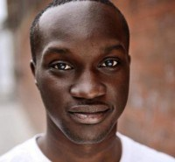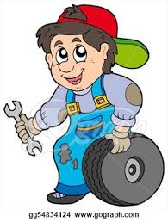

My name is Iqra. I live in East Croydon. I come from Somalia. I am now studying for my GCSEs.
I had a long journey to the UK - some places on the way were okay, some were difficult. In July, it will be two years since I arrived here.
I met my best friend here in Croydon at a youth club. She comes from Congo. I feel good here because I made many friends from different countries.
Last year, I helped during Refugee Week. I went on stage to welcome people and introduce bands for the Celebrating Sanctuary Festival on the Southbank. I told people what refugee week is about.
I like to help people, especially my best friend. I helped her and I gave her advice. We support each other.
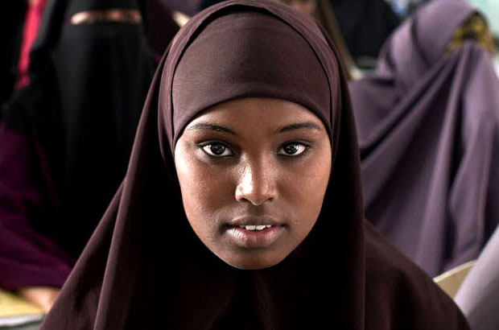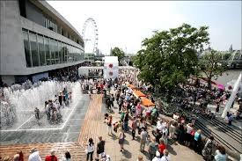

My name is Abdul. I live in Norbury. I come from Afghanistan. I arrived 3 or 4 years ago. I am an ESOL learner and I am also studying for the GCSE exam in Maths.
I came to the UK in a lorry. It was really hard and scary. It was dangerous because I could not breathe properly.
I have made lots of friends here. I am also learning martial arts and I take part in competitions.
When I see elderly people crossing the road, I always offer to help them. I also give up my seat for elderly people in the bus.
When I arrived in Croydon, other refugees translated for me and helped me to know the way to go to places. Now I am the one translating for my friends when we are at youth groups together.

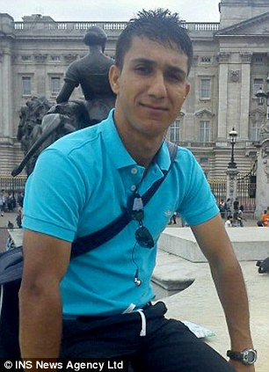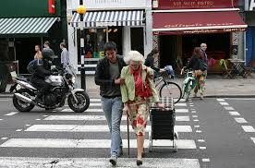
My name is Samir. I am 18 years old. I come from Sudan. I have been in the UK for almost two years since I arrived in September 2013. I go to college and I am an ESOL learner. I live in Norbury.
I have made friends in school and also at football sessions. My friends come from different countries, some are from Africa and some are from Europe.
I like to help my friends, especially when they are sick I like to cook for them. I also volunteer for a youth group in Tooting. I do shopping for food and cooking for the group. I also explain games to others during the group. Some people there help me with my homework.
I also worked for a charity shop for one month last summer. I am a peer mentor at my college and I help the new ESOL students.
When I arrived to the UK, I was helped by someone else who speaks Arabic. He helped me to find my way and he also offered me food and paid for the bus for me.

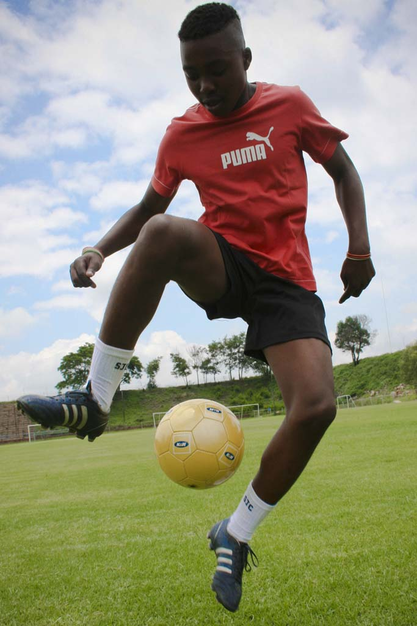

My name is Mohamed. I am 23 years old and I come from Iraq. I fled Iraq in 2009, because things there were not good for me and my family. I travelled through Syria and then I arrived in Britain.
I started working as a newspaper delivery man and then I worked in a restaurant. After a while I volunteered in an Oxfam charity shop. I am also doing various other volunteering activities.
I am a Refugee Week Young Ambassador. I talk to classes at college about refugees. We are organising a performance for Refugee Week this year. It will be about the migrants crossing the Mediterranean Sea. I help the artists and I will welcome the people to our event and explain to them what we do.
I volunteer for a football youth group on Sundays. There are people from all ages and I make sure they have fun and that they actually mix with each other. Now it feels like we are a family.
I am a volunteer in a theatre group where people who have problems can come and it helps them to feel more confident.
I am also volunteering for Unicef UK and I helped by organising a conference. The conference was called “The Power of Words” and ESOL students from my college took part.
It is really important for me to help other people. By sharing what I experienced with other students, they know I can understand their experiences and I can help them better. I know what newly arrived asylum seekers, who are studying English, are going through and because I didn’t receive any help when I arrived to the UK I know what they need and how to help them.
